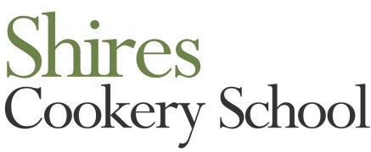
Telephone (01604) 621640
Email info@shirecookeryschool.com
Website www.shirescookeryschool.com
Course | June | July & Aug | September | October | November | December
Bread Level 1 £105 | Sat 28th | July - closed for refurb | Sat 13th | Sat 18th | Sat 8th
Bread Level 2 £120 |  | Aug – closed for summer | Sun 14th | Sun 19th
Chocolate Heaven £105 | Sun 29th |  | Sat 27th
British Baking £105 |  |  |  | Sun 5th
Christmas Baking £105 |  |  |  |  | Sat 1st
Fish Master class £120 | Sat 7th |  | Sat 20th | Sat 25th
Italian Cookery £105 | Sat 21st |  | Sat 6th | Sat 11th | Sat 15th
Perfect Pastry £95 |  |  |  | Sun 26th
Thai Cookery £105 |  |  | Sun 21st
Italian Christmas £105 |  |  |  |  |  | Sat 13th
Indian Cookery | Sun 1 fully booked |  | Sun 7th | Sun 12th
Vietnamese £105 | Sat 14th |  |  | Sat 4th
SHORT COURSES
Curry in a hurry £65 |  |  | Thurs 11th
Pasta Pronto £65 | Thurs 5th |  | Thurs 25th |  | Thurs 20th
Pie & Pint £65
Christmas Chocolates £65 |  |  |  |  |  | Sat 6th
Sausage making £55 | Sun 22nd |  |  | Thurs 23rd
Burger & Relish £55 | Sun 15th

